

Schools & Homes Energy Education Project/Solar-Active
Tell Me, I’ll Forget, Show Me, I’ll Remember, Let Me Do It, I’ll Understand. Chinese Proverb

PING PONG BALL FRONT ASSEMBLY GUIDE
FOR DOUBLE OR SINGLE SOLAR CAR
david@solar-active.com

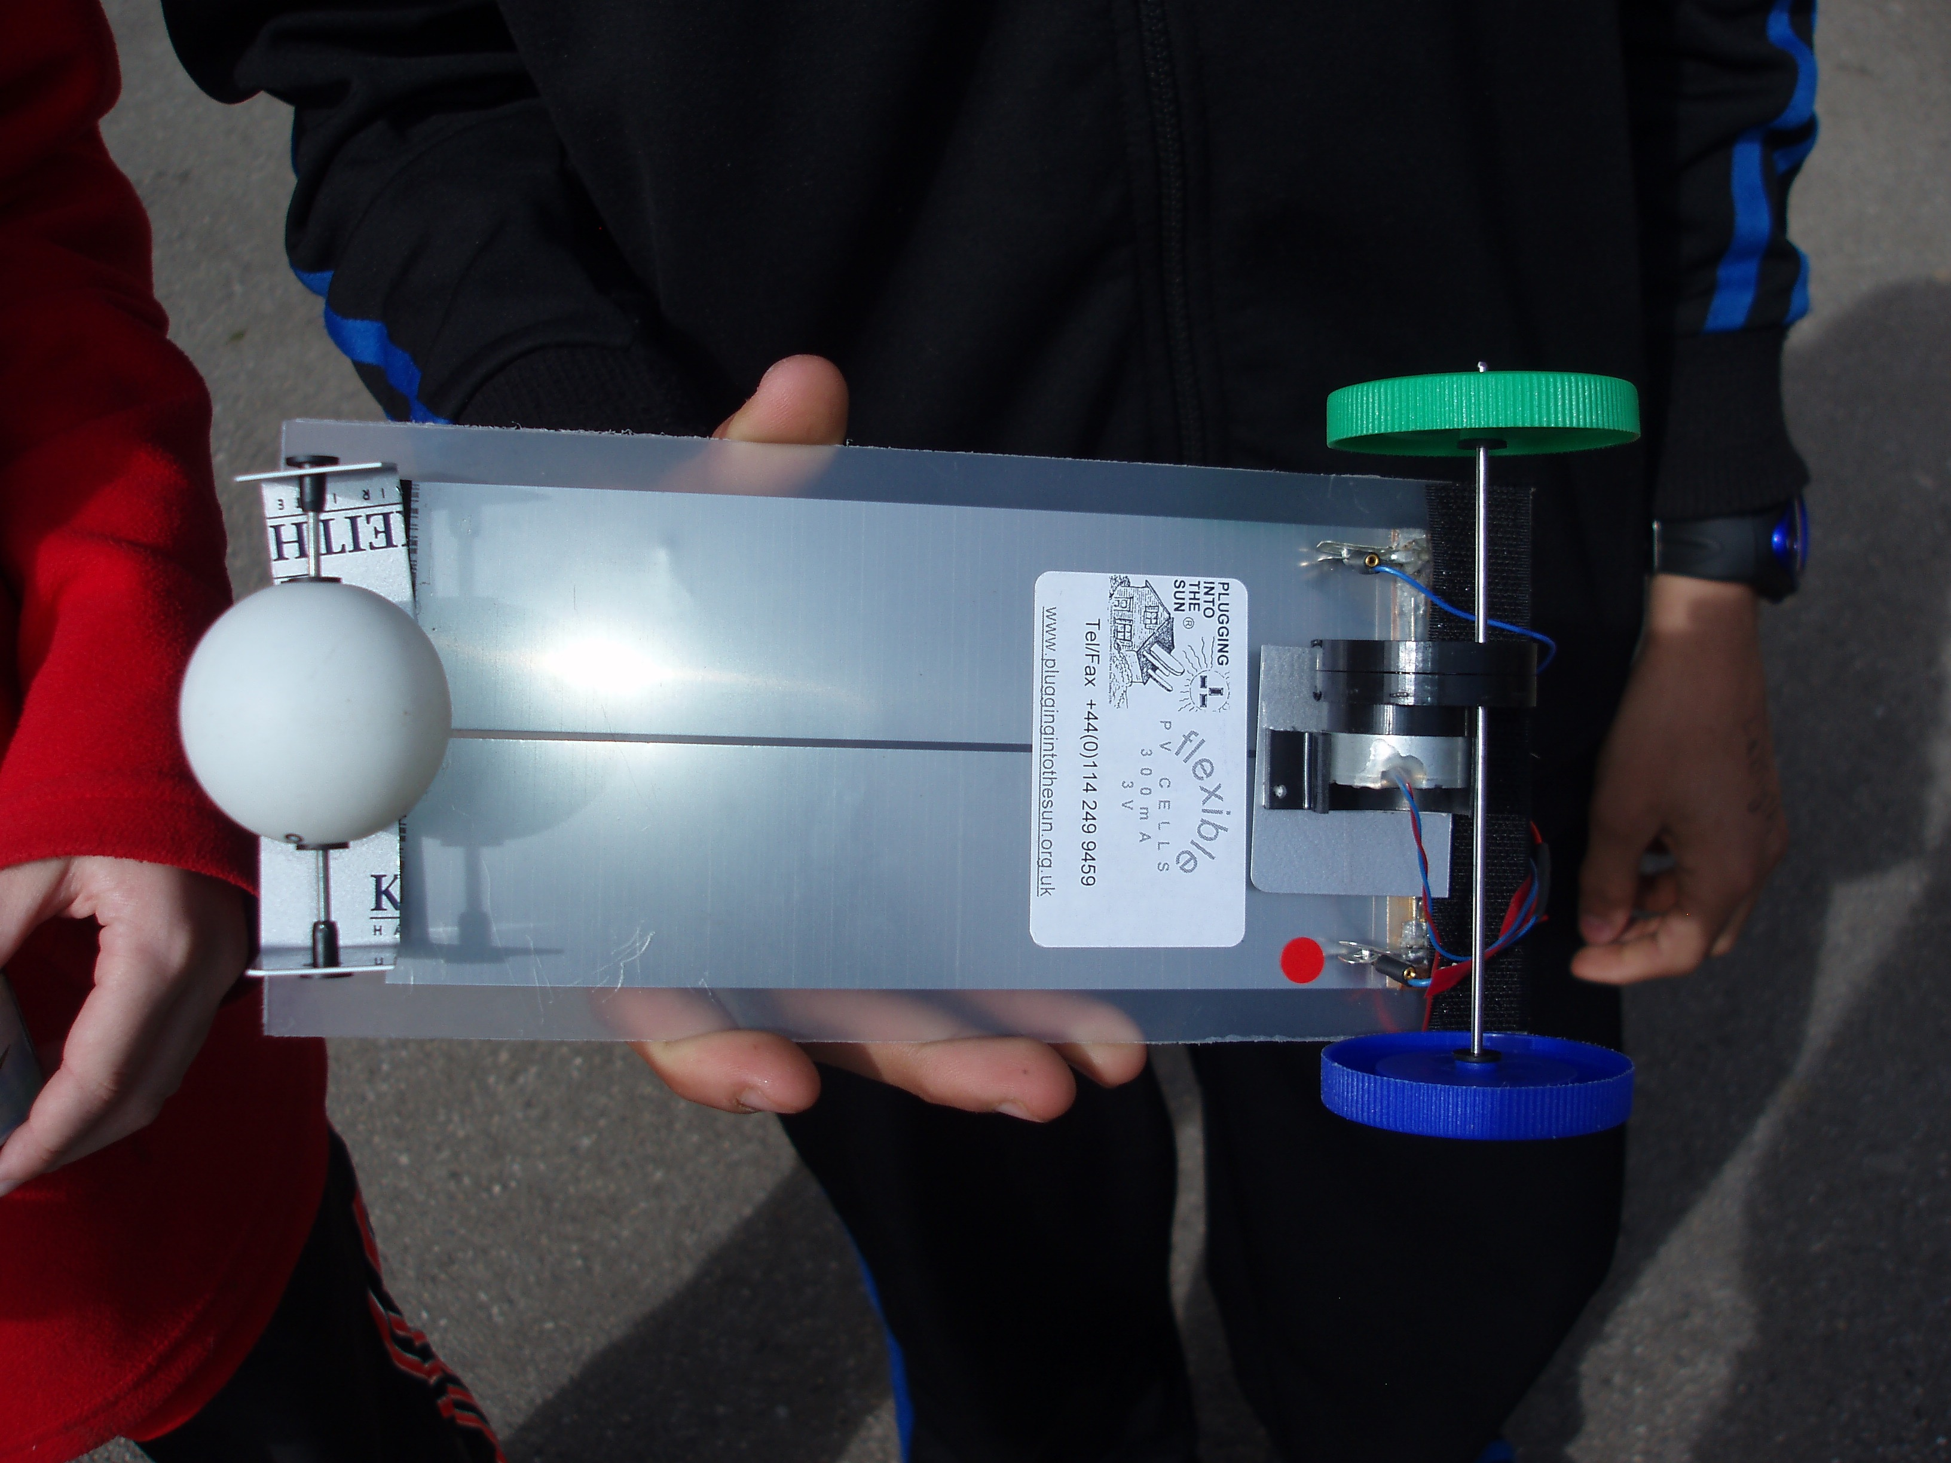

- Place a 2mm hole in ping pong ball.

- Push through a sharp ended tool to puncture another hole in the ball directly across from the 1st hole.

- Drill out holes so that the white, blue or red plastic insert with hole fits, with smaller end fitted into the two holes of the ball.
  - Use adhesive to secure. Careful not to block hole

- Place black reducer onto end of axle with smaller end facing inward.

- Place ‘L’ shape onto axle with short bend at bottom facing inward.

- Push axle through hole of insert and insert end of axle into opposite hole of ball. You may need to remove the other insert to do this.

- Place ‘L’ shape onto end of axle with smaller bottom end facing inward

- Place a black reducer onto end of axle with smaller end of reducer facing inward.

- Adjust axle so same length on each side of ball

- Attach ‘L’ shapes with smaller end with Velcro facing inward, with axle and ball onto front end [near terminals] of solar cell

- Test to check if ball spins smoothly without friction.

